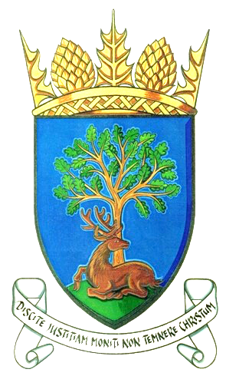

**Royal Burgh of Falkland & Newton of Falkland Community Council**

**Minute of Informal Meeting 14th April 2020**

**held at 7pm via conference call due to lockdown Covid-19**

**Welcome from Chair**

**Present:** Jim Brown, Peter Burman, Rod Crawford, Gordon Honeyman, Stuart Knowles, John Smith, Douglas Young

**Apologies:** Gavin Lawson, Kenny Lumsden

1. **Response to Fife Council Planning Dept re Stewardship Trust application for 4 years extension**

We submitted a note for CC to be a statutory consultee but we only had 2 weeks to respond to FC by 1 April. JB and RC drafted response but due to quick turnaround could not consult all CC members before submitting letter. Stewardship Trust have already had a 3-year temporary planning application, and are now applying for an additional 4 years. Due to Covid-19 there will be no events taking place at the Stables this year. CC would need strong evidence that their traffic plan works, namely to use new ‘gateway’ at Pillars Junction for traffic travelling to events and also to have a parking plan in place. Discussion took place re residents’ parked cars in West Port. Should these cars be parked elsewhere, i.e. develop green space at bottom of Hill Road for parking with electric charging points, or continue to allow parked cars as they act as a brake slowing down moving traffic through West Port? If the Estate’s traffic plan works then there should be less through-traffic in West Port. Situation ongoing.

**2.** **Clock Tower**

New owner of town hall wishes to take responsibility for clock tower. FC will take responsibility for the clock which will therefore continue to be Common Good Property held on behalf of the community. There remains a residual anxiety about maintaining or repairing the historic mechanism of the clock. Would a better solution be for a local community organisation, e.g. the Falkland Society, to take responsibility for clock?

**3. Trees at East Loan – 2 willows with overhanging branches bending over road**

It was noted that we had received 5 estimates from tree surgeons for removal of dangerous trees. In discussion, if CC took ownership of them, would we be making a precedent for any future work? CC had agreed to get arborist work done; it is not our responsibility for maintaining trees. FC don’t own them but do maintain them.

In summary JB will contact FC and if no suitable response we will get work done for these 2 unstable trees only.

**4. Fountain**

Water remains switched off so no water bill is being accrued. Chair, CC, had convened a successful meeting with David Clark, Chair of Community Development Trust responsible for Community Hall and with PB, Chair, and Gerardine Clark, Treasurer, of the Falkland Society. The Falkland Society is willing in principle to take responsibility for the fountain, but need to check that their trust deed would allow this. Probably it would be allowed, as the Society’s principle duty is the preservation of Falkland’s heritage. Similarly, it will check whether it would be allowed by its trust deed to assume responsibility for the clock.

**5. Covid-19**

Falkland has a support group with an information leaflet issued to every household. The Falkland group will be taking referrals from FC for the Howe of Fife – delivering shopping etc. Residents can drop off food parcels outside Smart Cookies Nursery between 8am – 5pm daily – drop off what you have excess of/take what you need.

Distribution of shopping, for those shielding, around village is working well – distribution through young cricket club members. Can we identify any vulnerable people?

**6.** **Sustrans Report back**

There is a proposed cycle route between Bridge of Earn and Newburgh with the first phase being Bridge of Earn to Aberargie. It is still in design process and there are no guarantees it will be followed through. Due to our current situation, a massive amount of money is being spent, will there still be money for this project? SK will draft a response on behalf of CC to the consultation paper. It is important that the government are creating walk/cycling routes where people live not just investing in dualling the A9.

**7. War Memorial**

The wreaths from November 2019 are still currently placed at war memorial on Brunton Green – agreed to leave there until just before next Remembrance Day.

**8.** Thanks given to J Brown for stepping up as acting secretary. A councillor can only be nominated and given a permanent role when the CC meeting is formal and held in the public domain.

**9.** CC acknowledge Irfan’s contribution to the community from his shop.

Next meeting 12th May 2020