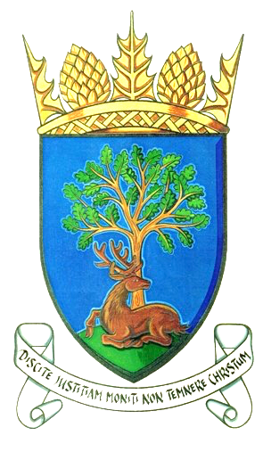
Royal Burgh of Falkland & Newton of Falkland Community Council

Minute of Meeting 12th May 2020
held at 7pm via conference call due to lockdown Covid-19
(public invited to attend)

Welcome from Chair

Present: Jim Brown, Peter Burman, Rod Crawford, Gordon Honeyman, Stuart Knowles, Douglas Young

Councillors: Cllr A Heer Police: nil Residents:1

2 Apologies: Kenny Lumsden, John Smith, Cllr D MacDiarmid

Agenda Item | Discussion | Action
3  Declarations of Interest | None | None
4  Minute of Previous Meeting | February minute approved.  April informal meeting - minute approved. | Noted
5 Matters Arising from previous meeting not on agenda | None | Noted
6  Police Matters | Police report circulated. PC Phil Parker has taken up a new role as Firearms Enquiry Officer. PC Dawn Doherty has taken over as Community Officer for Howe of Fife and Tay coast. | Noted
7  Action Register | No updates | Noted
8  Update on St John’s Works site | No updates – item will be removed from agenda and added when information to report. | Noted
9(i)  Community Council Issues | 1. Stewardship Trust Extension update – Chair read from a letter to CC from N Crichton-Stuart received on 25 April. Chair will plan a zoom meeting with NCS, Joe Fitzpatrick of Falkland Estate and J Brown.  2. Common Good Fund and Fountain – no update.  3. Clock Tower – no update.  4. Tree Survey – JB has communicated with Cllr MacD who has sent an email to Lorraine Evans, Tree Officer at FC - currently awaiting a response from her. | Noted - ongoing  Noted - ongoing  Noted - ongoing  Noted - ongoing
9 (ii)  Cllr D MacDiarmid’s report | Cllr MacDiarmid sent his apologies.  A resident has been in touch with Chair and Cllr MacD re an issue of anti-social behaviour at weekend at a residence in Lomond Crescent whereby Police were in attendance. Chair has raised issue to Cllr MacD who has written to the head of housing at FC. | Noted
9 (iii) Resident’s  Issues | Resident B Gilchrist asked if there has been any follow up on finding a detailed map of Balmblae and its land owners? JB informed her Cllr MacD has tried to refer the issue to M McArdle of FC – we may have to wait until the Covid lockdown is over before we receive a response. Meantime JB has a map he can forward to BG which may be useful. | Noted
10  Falkland’s Future Implementation Report | SK responded on behalf of CC re proposed cycle route between Bridge of Earn and Aberargie. He had received 2 responses from CC members supporting the project with no negative responses – this has been submitted.  A design brief has been sent to JB who would like to reorganise part of it. Should we hold another stakeholder meeting? – wait till after Covid.  JB - Edge of village parking - last piece of info we needed was a third party verification certificate which was close to being signed off. An evaluation of drainage in the field to take place to ensure the design of car park will not affect drainage. We can give planning one more go but we do not want any more costs arising. | Noted – ongoing
11  Planning, Listed Building and Conservation Issue | Nothing to report. | Noted
12  A.O.C.B. | PB – there has been much confusion re when our refuse was being collected. Cllr Heer has been advised public should check the bin calendar on FC website on Sunday evening. On Saturday 2nd May we had an unscheduled green bin collection which was due to the dedication of the refuse men – well done to them!  PB – Around 400 National Trust for Scotland employees are at risk of redundancy as a result of the Coronavirus. There will be a reduced number of openings in properties this year. PB will send a message of empathy and concern to Wendy Purvis of NTS as she has been extremely supportive to CC. | Noted  Noted
Next Meeting: 7pm Tuesday 9th June 2020 - Virtual meeting

