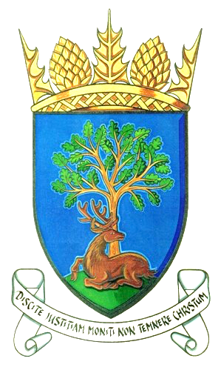

Royal Burgh of Falkland & Newton of Falkland Community Council

Action Register April 2019

Minute Reference | Action | Owner | Anticipated Completion Date | Status Report | Date Closed
13.11.2018  Item 7.i | Discharge of effluent into burn. | JS | ongoing | KL asks if the estate will share their minute of meeting with SEPA to allow us to see their approach to the issue.
13.11.2018  Item 7.iii | Phone box at Newton of Falkland. | PB and JS | ongoing | Meeting at Newton on 24th April re the proposals for their village – an ideal time to consult with them.
13.11.2018  Item 7.v | Installation of playpark at Balmblae | DMacD | ongoing | Park open. On the bridge planks replaced, handrail still to be repaired. Still awaiting repairs of access road.
15.01.2019  Item 6.1 | Return of Christmas Lights letter to be sent to Visit Falkland | KL | ongoing | CC still waiting response from Visit Falkland. Their AGM is postponed until 11th May – CC hope to resolve then.

