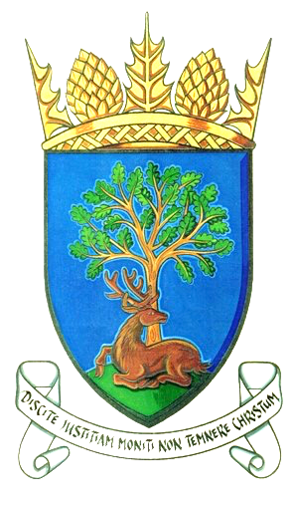
Royal Burgh of Falkland & Newton of Falkland Community Council

Minutes of Meeting 11th September 2018
held at 7pm, Falkland Community Hall

Present:
Rod Crawford (in Chair), Margo Brunton, Doug Young, John Smith, Ken Laurie.
Apologies:
Gavin Lawson, Marion Robb, Stuart Pearson, Peter Burman, Claire McLeod.

In Attendance:
Councillors: Donald Lothian, Andy Heer, David McDairmid Residents: 2 individuals Police Officers: Emma Fisher, Phil Parker.

Agenda Item | Discussion | Action
3  Declarations of Interest | John Smith in relation to any items relating to Falkland Stewardship Trust, Falkland Society and Falkland War Memorial Trust. | Noted
4  Minutes of Previous Meeting | Minutes of the previous meeting were duly approved | Noted
5  Matters Arising | Matters arising from previous meeting not on agenda | Nil
6  Police Matters | Police Report – comprehensive written report summarised by constable Emma Fisher | Noted
7  Action Register | - Discharge of effluent into burn | JS gave brief update on progress. Estate tendering for the necessary work to connect sewage to main sewer. In hope that work will be complete by end of winter.
 | - Issue of surface water on High road, Hill road and at various points of the village. | Apparently issue on High Road has been fixed by Fife Council. Numerous blocked drains, East Port and Lomond Crescent cited as examples. It’s Fife Council’s responsibility to check on regular basis.
 | - A review of the number and siting of grit bins is to be carried out in August and September | Community Council would prefer all grit bins remain. Donald Lothian to give feedback to Fife Council.
 | - Overhanging tree at old Backdykes road | Donald Lothian reported that housing services will carry out review and take action if appropriate.
 | - Phone Box at Newton | J.S. gave feedback, no progress as yet.
Royal Burgh of Falkland & Newton of Falkland Community Council

Minutes of Meeting 11th September 2018
held at 7pm, Falkland Community Hall

Agenda Item | Discussion | Action
7  Action Register | - Armistice Ceremony | J.S gave progress report.
 | - Concern has been raised to the community council about safety of trees in grounds of Meadowfield House that border neighbouring properties | KL reported that following an informal approach, householder gave reassurances that the trees are regularly assessed. Matter closed.
 | - Litter bins in cemetery always seem to be full | Donald Lothian to ask Fife Council to review frequency of emptying. Ongoing review
 | - Old Town Hall sale | KL has raised issue with Keith Winter re clock Tower is on Common Good Register no response received.
7  Resident’s Issues | - David McDairmid’s Case Report | In D McD’s absence nil reported
 | - Margo Brunton’s Case Report  - Christmas lights discount offer received from Blanchere.  - Christmas lights junction boxes to be inspected  - Rights of Way – Craig Gilbert wishes to replace a seat on path back of Old Backdykes Road | It was decided no new lights are needed at this time  JS to liaise with electrician  Agreed
8  Post Charrette Progress Report | - A funding application has been made to Sustrans “Community Links” programme by KL for £325,134 to further the work of the recent charrette. If successful, this will allow detailed designs to be developed in conjunction with members of the community.  - Another opportunity exists for securing funding for the construction of an “edge of village” carpark. The potential sites identified at the charrette will be subject to a robust option appraisal. | Noted  Noted

Royal Burgh of Falkland & Newton of Falkland Community Council

Minutes of Meeting 11th September 2018
held at 7pm, Falkland Community Hall

Agenda Item | Discussion | Action
9  Planning, Listed Building and Conservation Issues | - Mr J McClymont, Clardale, High Street – erection of a wall - retrospective.  - Mrs M Dale, Mill House, Horsemarket – Listed building consent for replacement conservatory roof and installation of rooflight.  - Mr D Heaton-Armstrong, The Steading, Ladywell House – Single storey side/rear extension to dwelling house.  - Mrs L Robb 2 lomond Fields, Hill Road – Change of part of dwellinghouse (class9) to hairdressors (class 1) including installation of replacement doors. | All noted no objections raised.  PB to write to Fife Council raising Community Council objections
10  A.O.C.B. | - The proposed sale by NTS of Old Town Hall  - KL explained the arrangements for the impending Community Council Elections | KL to seek clarity from Fife Council re the building’s Clock Tower being on the Common Good Register
11  Matters of Interest for Noting |  | Nil Noted

Next Meeting: 7pm Tuesday 9th October 2018
Venue: Falkland Community Hall

