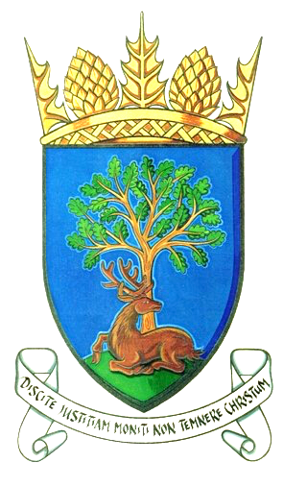
Royal Burgh of Falkland & Newton of Falkland Community Council

Minutes of Meeting 9th October 2018
held at 7pm, Falkland Community Hall

Present: Peter Burnam, Rod Crawford, Ken Laurie, Gavin Lawson, Kenny Lumsden, John Smith,
Douglas Young

Apologies: Claire McLeod

In Attendance:
Councillors: David McDairmid, Donald Lothian Police: no Residents: 3

Meeting chaired initially by Cllr D McDairmid. After election of new office bearers, the chair was handed over to Rod Crawford.

As this was an inaugural meeting only items of any other business were discussed.

Agenda Item | Discussion |  | Action
3  Declarations of Interest | John Smith, Peter Burman in relation to any items relating to Falkland Stewardship Trust and Falkland Estate. |  | Noted
4  Minutes of Previous Meeting | Not discussed.
5  Matters Arising | Election of office bearers  Chairperson – Rod Crawford was proposed by Peter Burman. Seconded by Ken Laurie.  Vice Chair – Ken Laurie was proposed by Peter Burman. Seconded by Rod Crawford.  Secretary – Ken Laurie was proposed by John Smith. Seconded by Peter Burman.  Treasurer – Claire McLeod was proposed by Rod Crawford. Seconded by John Smith.  K Laurie happy to be Secretary on basis there would be a minute secretary. |  | All nominees accepted their role.
6  Police Matters | Police Report circulated |  | Noted
7  Any other business | - Marion Robb to be given £100 for the annual fireworks at Newton.  - Christmas Lights on Brunton Green  - 100th anniversary of end of 2nd World War – Does council want to buy a bench for Brunton Green?  - Display board at bottom of Cross Wynd in tatty condition.  - Town Hall for sale. Essential to enquire why was it sold to National Trust to begin with as Tower is on common good fund but building isn’t.  - No signage “No dogs” at school field. Old sign may have been removed when fencing was replaced. Also at old cemetery – signage required. | KL to see CM re payment  Decision passed to CM  JS to find out if funding can be sought from War Memorial Trust. In principle all agreed. KL to ask M Brunton to follow up.  Charette will be looking at streetscape/signage within village.  CC to write to Fife Council.  Cllr DM to investigate
9  Planning, Listed Building and Conservation Issues | Malt Barn, Newton of Falkland – proposal to change from bar/restaurant to dwelling house. Previous planning application had expired but application resubmitted. There is a right of way in Malt Barn back garden. | CC to write to Fife Council re right of way

Agenda Item | Discussion | Action
9  Charrette phase 2  Community Links Programme | KL gave a detailed report on progress to date | Noted
Next Meeting: 7pm Tuesday 13th November 2018
Venue: Falkland Community Hall

