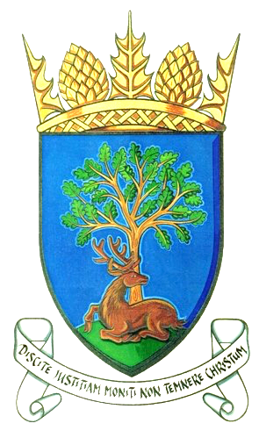
Royal Burgh of Falkland & Newton of Falkland Community Council

Minutes of Meeting 13th November 2018
held at 7pm, Falkland Community Hall

Present: Peter Burman, Rod Crawford, Ken Laurie, Kenny Lumsden, John Smith,
Douglas Young

Apologies: Gavin Lawson, Claire McLeod

In Attendance:
Councillors: Andy Heer, David MacDiarmid, Donald Lothian Police: no Residents: 3 NTS Representatives: Wendy Purvis, Antonia Laurence-Allen

Agenda Item | Discussion | Action
3  Declarations of Interest | Rod Crawford in relation to planning application. | Noted
4  Minutes of Previous Meeting | Approved by all. D Young first approved, seconded by P Burman. | Noted
5  Matters Arising | Matters arising from previous meeting not on agenda. | None
6  Police Matters | Police Report will be displayed on notice board outside Town Hall. There are ongoing matters being dealt with by the police. Police will hold a Community evening on Thurs 6 Dec from 5 – 7 pm in hall offering safety advice, community speed awareness, etc. | Noted
7  Action Register | i. Discharge of effluent into burn | Ongoing
 | ii. Overhanging tree at Back Dykes | Ongoing
 | iii. Phone box at Newton of Falkland | Ongoing
 | iv. Christmas lights at Brunton Green | Ongoing
 | v. Playpark at Balmblae had previously been intimated it would be installed by 21 Nov. Playpark committee frustrated nothing has been done so far after all their fundraising efforts. | Ongoing  Cllr MacDiarmid to speak to Fife Council.

Agenda Item | Discussion | Action
8  Common Goods Regalia | Some years ago North East Fife District Council gave several objects to the National Trust of Scotland which are currently on display in the Town Hall. As said Town Hall is on the market the NTS wish to transfer the custodianship of these objects back to Falkland Community Council. | NTS to put proposed transfer of objects in writing to CC.
9  Resident’s Issues | David MacDiarmid’s Case Report  Issues around Falkland noted – broken tarmac on roads, potholes, blocked drains, 2 spars missing from bridge at Balmblae playpark.  - Bush opposite school playing fields is obscuring view at bus stop. It is not in someone’s garden.  - Concern from residents of rising crime in Falkland.  - Flood Action Group - Fact finding group came from Southern Ireland and met with Cllr MacDiarmid.  - Currently there are 5 or 6 street lights out in Pleasance.  - No dogs allowed signs – new signage has been ordered.  Issues reported by residents  2.1 Top of Liquorstane – tarmac surface deteriorated/rutted.  2.2 On bin collection days issues with access to homes from Stag Inn to Balmblae for bin lorries. Also, when bin lorry reverses residual liquid seeps out and runs down hill at the Stag Inn.  2.3 Remains of tree on Stag Green – heavy timber has been removed but lighter wood still to be removed.  2.4 Spars on bridge at Balmblae – 2 are damaged.  2.5 Street light at bottom of Liquorstane – bulb needs replaced.  2.6 Residents have commented on the great efforts made at the War Memorial Centenary service. | Discussed and noted.  Bush to be chopped down.  Police aware and monitoring.  Discussed and noted.  To be actioned.  Ongoing  Noted  Noted  Noted  Noted  Noted  Noted
10  Charrette phase 2  Community Links Programme | KL gave a detailed report.  - Draft designs for edge of village carpark to be submitted by 31.01.2019. Various sites identified, surveys to take place. Next Charrette meeting Wed 12 Dec.  - Factory site has been sold to developer Springfield Properties, a Scottish based company. There will be a consultation meeting in hall on Thurs 20 Dec at 7pm. They have intimated planning will be submitted early 2019 with building commencing Oct 2019. RC and KL are meeting with company on 15 November to find out time frames. | Full discussion took place.  Full discussion took place.

Agenda Item | Discussion | Action
11  Planning, Listed Building and Conservation Issues | 1.Trees at Whinstone House – application to reduce height of 2 Cypress trees by 25%  2. R Marshall – application to reduce crown height of 2 Beech and Sycamore trees.  3. R Crawford – planning application discussed. | No objections to applications.
12  A.O.C.B. | 1. J Smith gave cheque from Falkland War Memorial Trust to CC for expenses. | No action.

Next Meeting: 7pm Tuesday 11th December 2018
Venue: Stuart Room, Falkland Community Hall

